**DOCUMENTATION**

***(Mobile Development)***

***(Group 2)***

**Members:** Cruz, Elissa Mae C. **Section:** 3.3BSIT

Fajardo, Anthonette Mae R.  
 Galera, Aaron Gabrielle A.  
 Leocadio, Micah Mae J.  
 Llona, Rhene F.  
 Morente, Mc Jayster A.  
 Umpar, Aina A.

**Stage 1: Draft Output**

*(November 12 - November 15)*

|  |  |  |  |  |
| --- | --- | --- | --- | --- |
| **Tasks** | **Assign To:** | **Date (Assign)** | **Date (Finished)** | **Contributors** |
| **Brainstorming** | All Members | November 09  (Thursday - 10:00 AM) | November 09  (Thursday - 11:00 AM) | Cruz  Galera  Llona  Umpar |
| **Market Research** | Galera  Fajardo | November 12  (Sunday - 1:20 PM) | November 14  (Tuesday - 9:26 PM & 10:04 PM) | Fajardo  Galera |
| **Mind Mapping** | Cruz  Llona | November 12  (Sunday - 1:20 PM) | November 14  (Tuesday - 12:08 PM) | Cruz  Llona |
| **Concept Testing** | Morente | November 12  (Sunday - 1:20 PM) | November 14  (Tuesday - 8:51 PM) | Morente |
| **Requirements Gathering** | Umpar | November 12  (Sunday - 1:20 PM) | November 14  (Tuesday - 5:17 PM) | Umpar |
| **Development Strategy** | Leocadio | November 12  (Sunday - 1:20 PM) | November 14  (Wednesday - 12:16A M) | Llona |

***Note:*** *If the name is highlighted, the member(s) didn't contribute to any task.*

**Creation Date (Draft):** November 12, 2023 (10:00 AM)

**Submitted in Google Class (Draft):** November 15, 2023 (12:23 AM)

**Suggest and Review by Prof. Perminola through Breakout Sessions and Email:** November 15, 2023 (10:00 AM onwards)

**2nd Step: Visual Table of Contents Diagram**

*(November 16 - November 23, 2023)*

|  |  |  |  |  |
| --- | --- | --- | --- | --- |
| **Tasks** | **Assign To:** | **Date (Assign)** | **Date (Finished)** | **Contributors** |
| **VTOC Diagram** | All Members | November 16 | November 20  (Monday - 1:27 PM) | Cruz, Llona |

**Submitted in Google Class:** November 20, 2023 (1:30 PM)

Stage 2: **UI/UX design**

**(November 18 - November 28, 2023)**

|  |  |  |
| --- | --- | --- |
| **Tasks** | **Date (Finished)** | **Contributors** |
| Wireframe | November 28, 2023 | Umpar, Galera |
| Mockup | November 28, 2023 | Cruz & Llona |
| Prototype | November 28, 2023 | Morente, Fajardo, Leocadio |

**Progress of Application**

**Features (1): Welcome Page**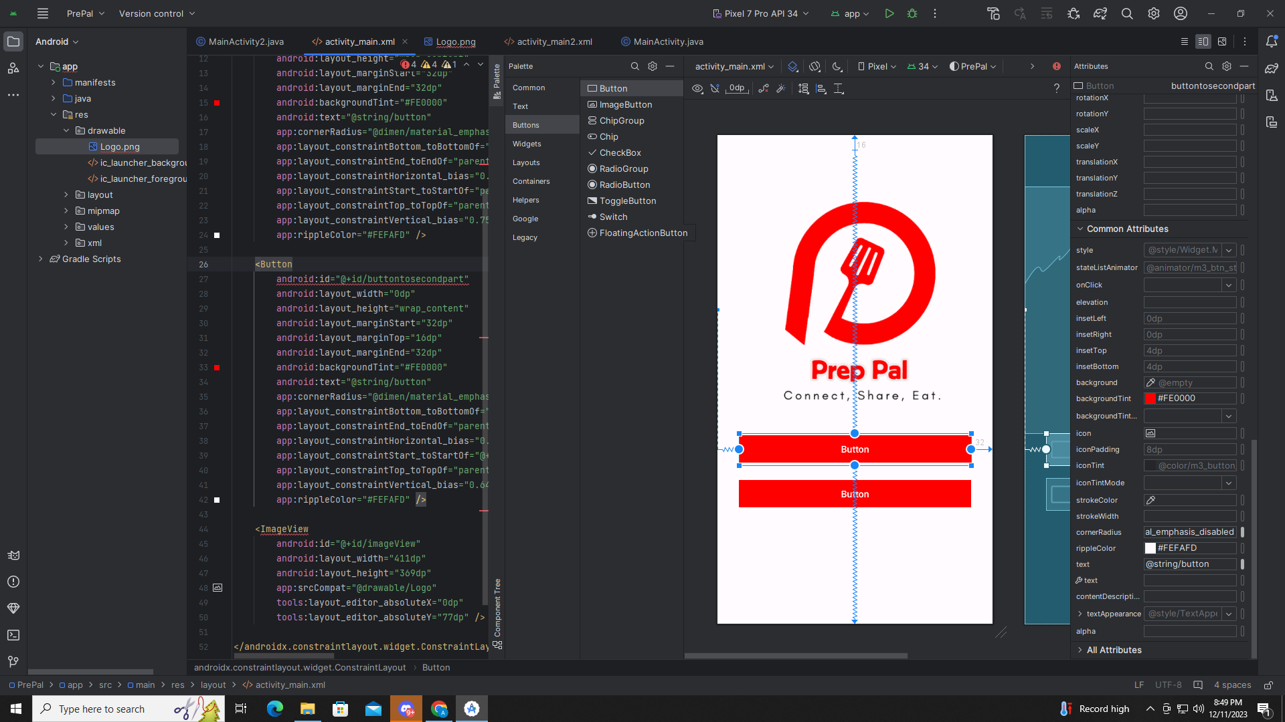

**Features (2): Sign In Panel**

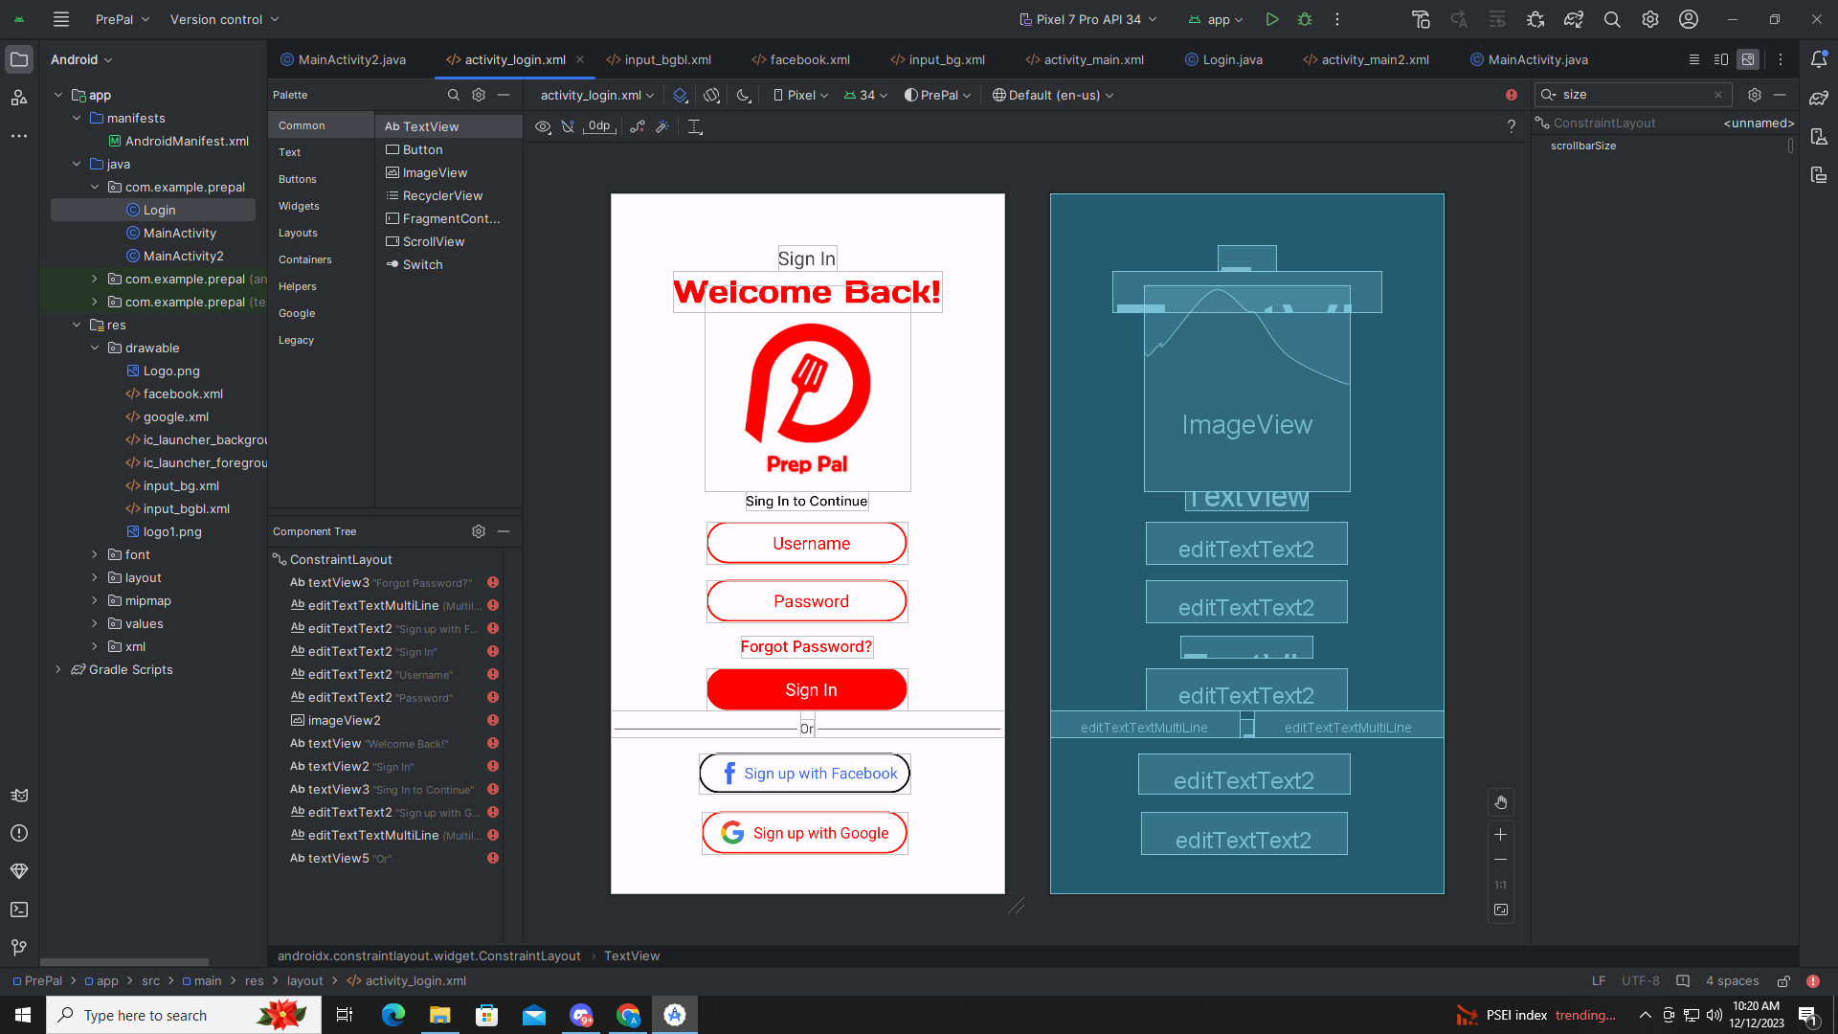

**Features (3): Sign Up Panel**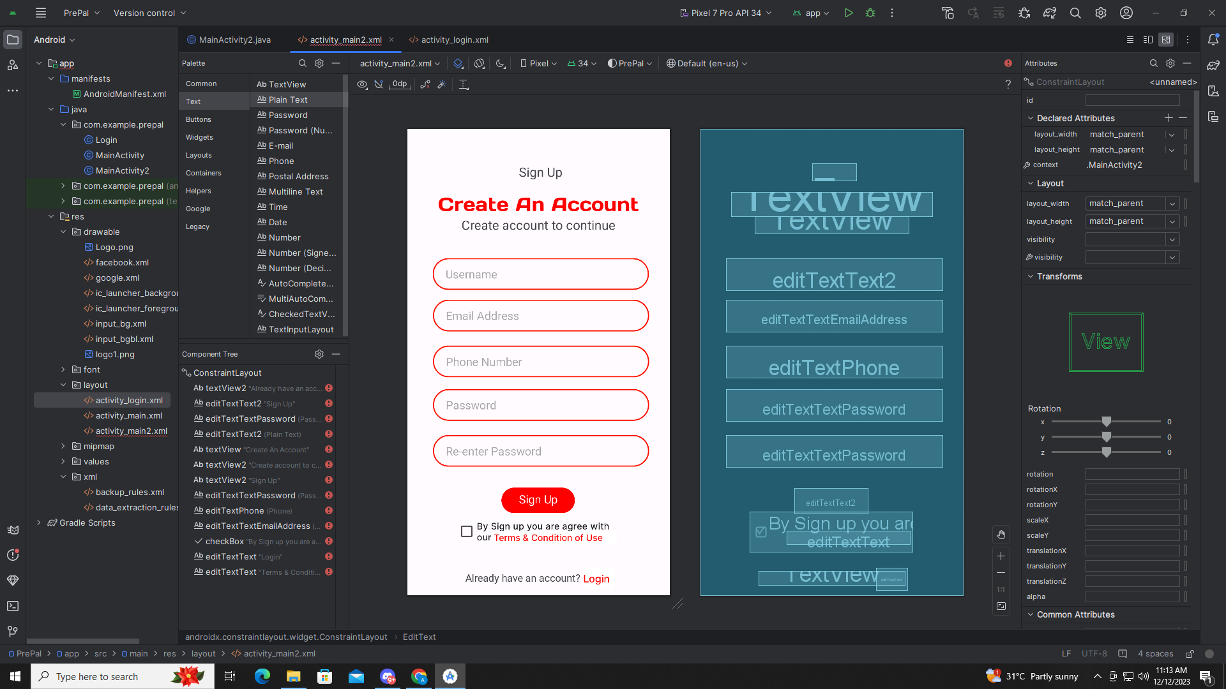

**Features (4): Profile**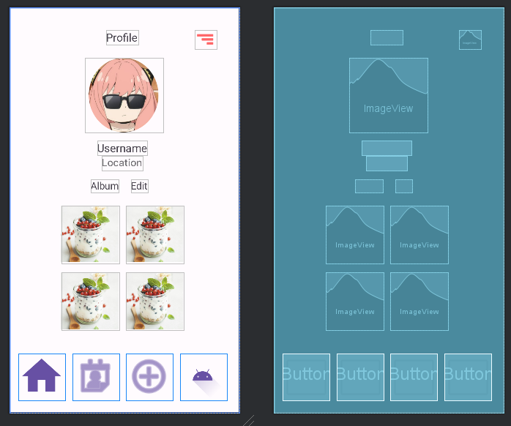

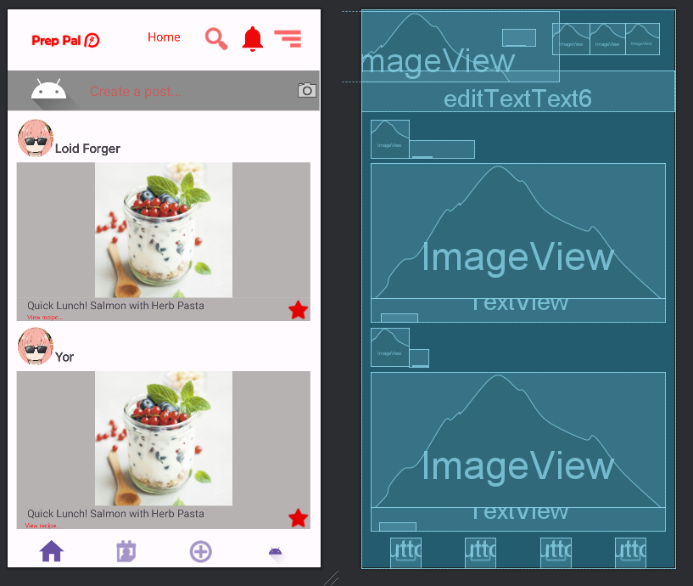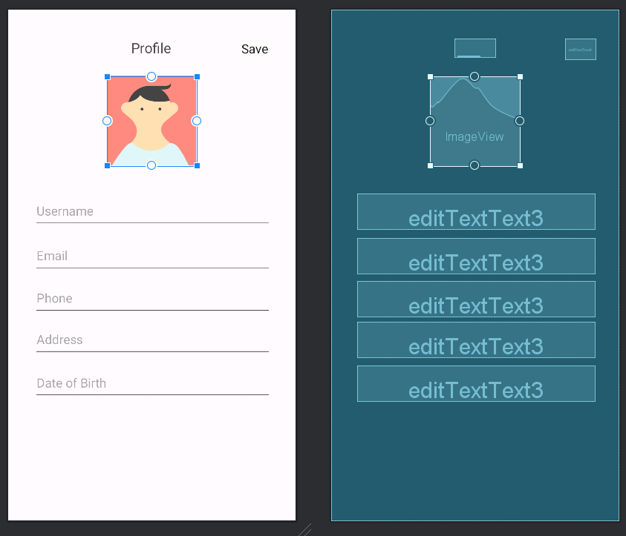**Features (5): Profile Edit  
  
  
  
  
  
  
  
  
  
  
  
  
  
  
  
  
  
  
  
Features (6): Home  
  
  
  
  
  
  
  
  
  
  
  
  
  
  
Features (7): Notification**

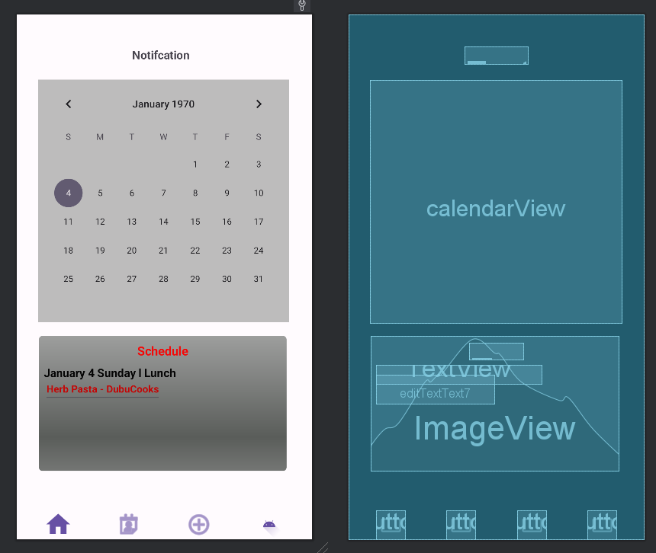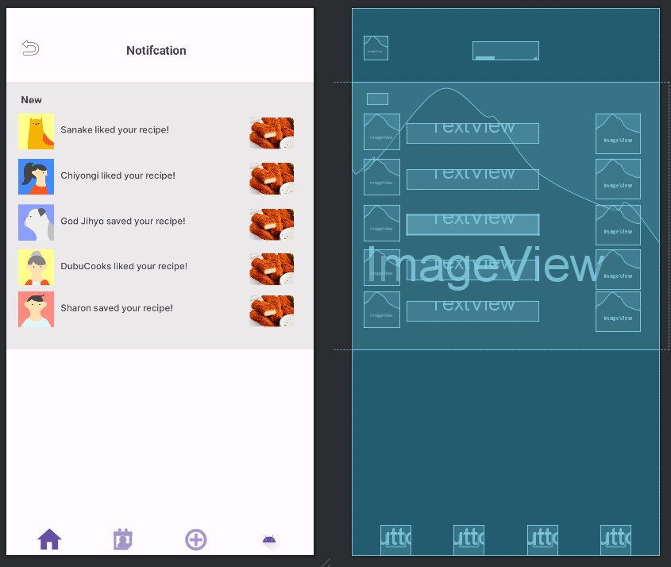 **Features (8): Schedule  
  
  
  
  
  
  
  
  
  
  
  
  
  
  
Feature (9): Saved**

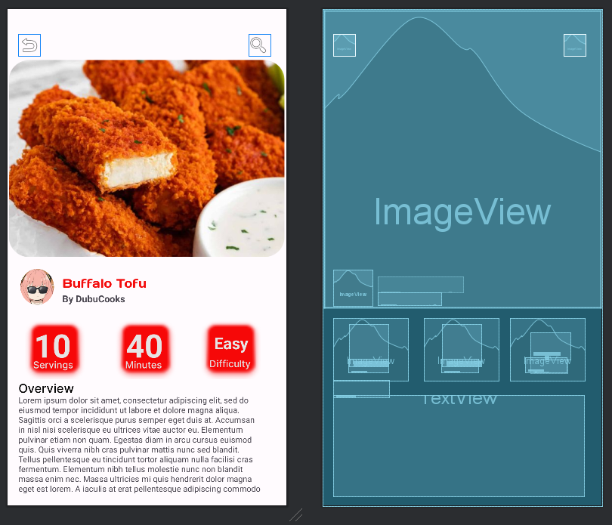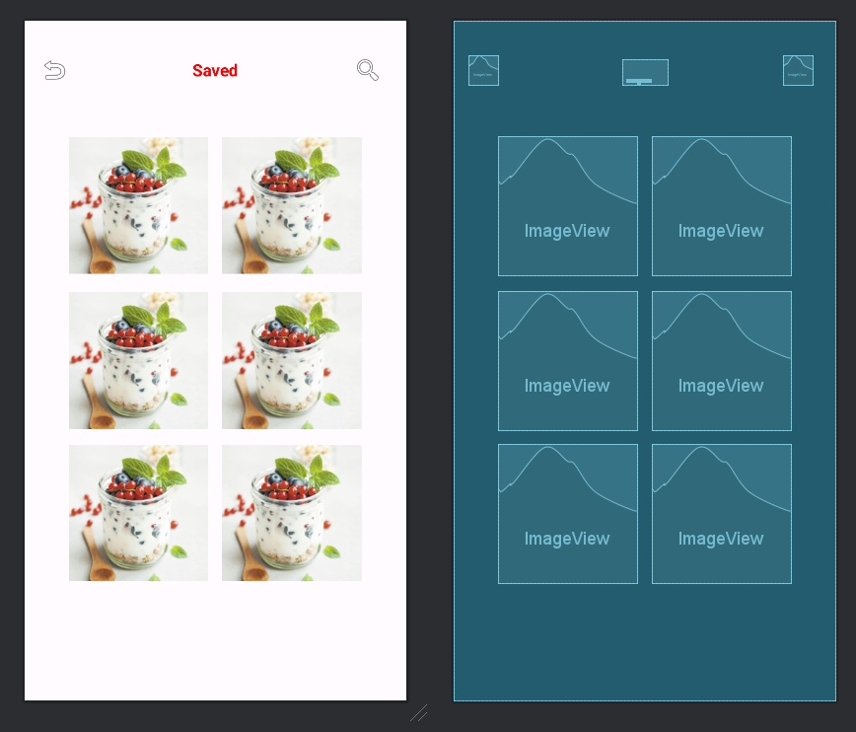 **Features (10): View Point  
  
  
  
  
  
  
  
  
  
  
  
  
  
  
  
Feature (11): View Point (Ingredient)**